


Hollow Shaft High Resolution Angular Encoders TGR72

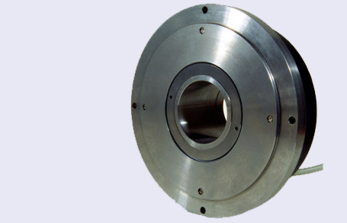

TGR 72 High Resolution Angular Encoder
Hollow Shaft
Resolution up to 3.600.000 pulses/revolution
Hollow shaft diameter | 50h7 mm
Outer diameter | 170mm
Input voltage | +5 V ± 5 % I ≤ 100 mA |  |  | +5 V ± 5 % I ≤ 150 mA
Output format | SI (11 µA) | SV (1Vpp) |  | DS (RS422)
Line numbers | 16384, 18000  36 RI |  | 18000, 36000, 90000, 180000, 450000, 900000
Accuracy | ± 2,5"
Max speed  shaft rotation | 1000 rev/min
Weight | 3,5 kg
Protection | IP64

